* On screen-overlay
* Results Display
* Match Schedule
* Match Highlights
* Map Preview (including Team and Player Information)
* Playing Team and Roster Information
* Match Intro
* In-Game Fragger Statistics
* Upper Stats
* Zone Timer

# ON-SCREEN OVERLAY

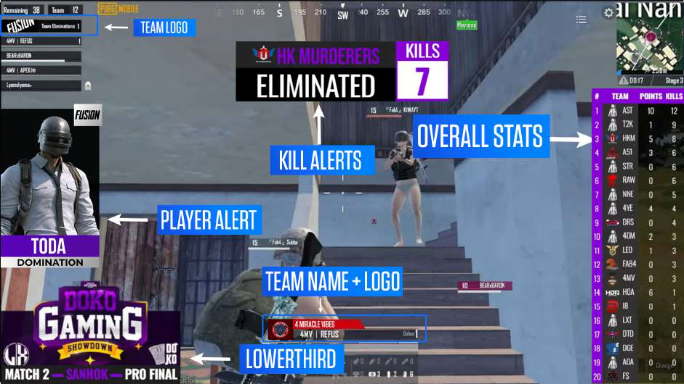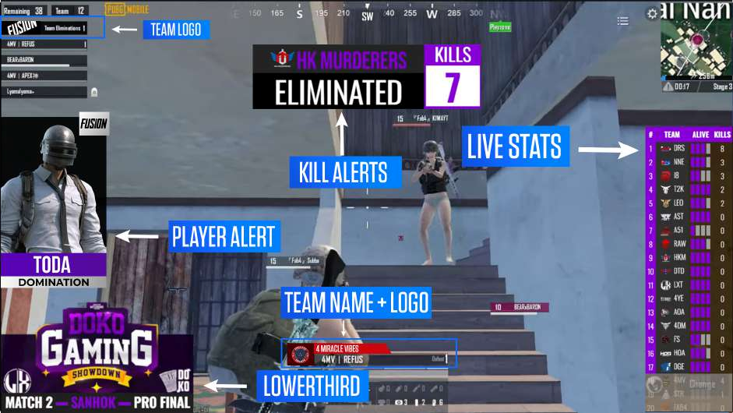

# RESULTS

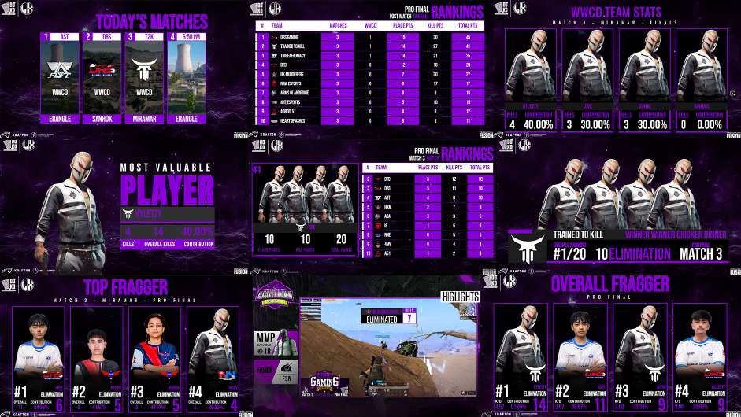

## MATCH SCHEDULE

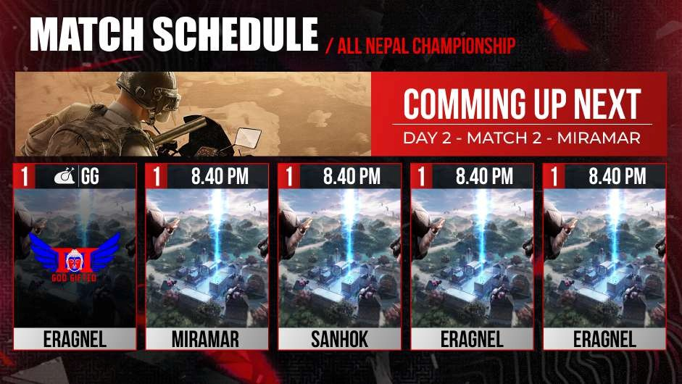

## MATCH HIGHLIGHTS-(FOOTAGE INCLUDED)

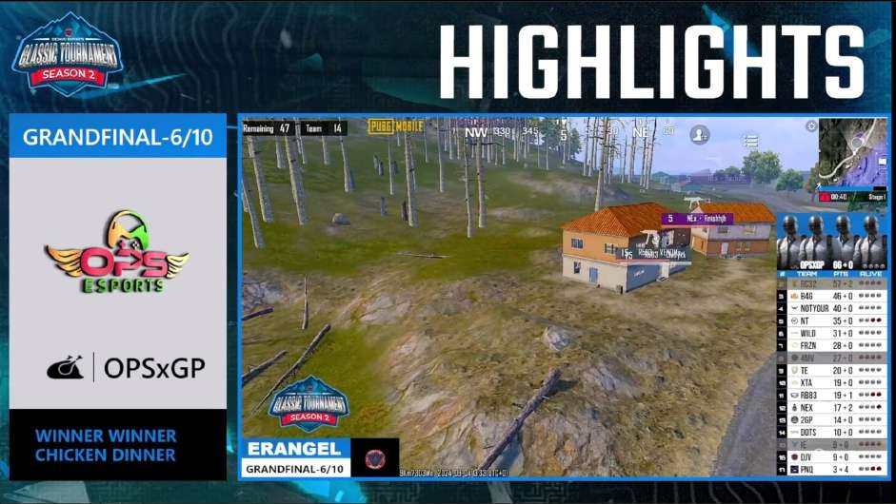

## MAP PREVIEW

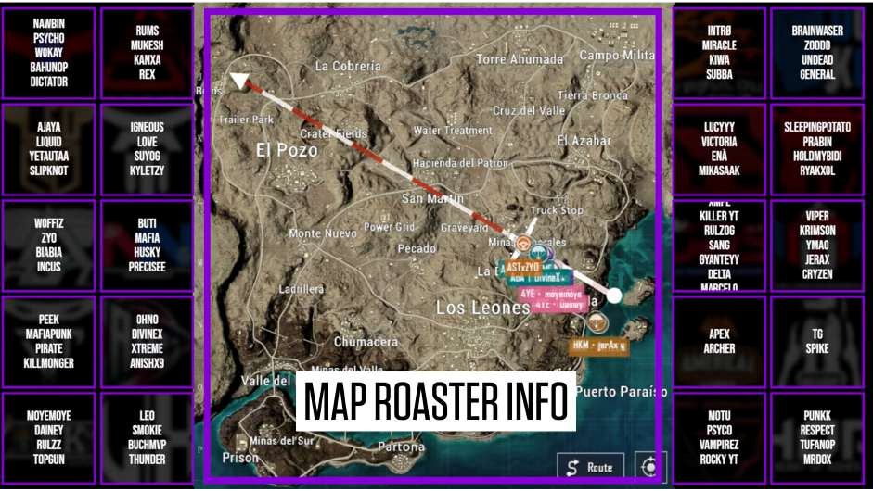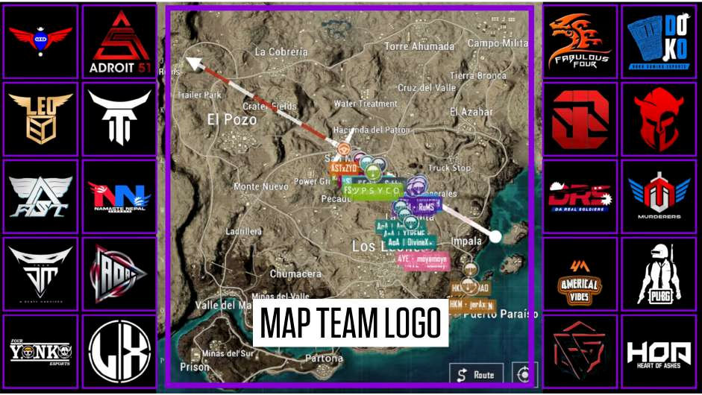

## PLAYING TEAM AND ROASTER INFORMATION

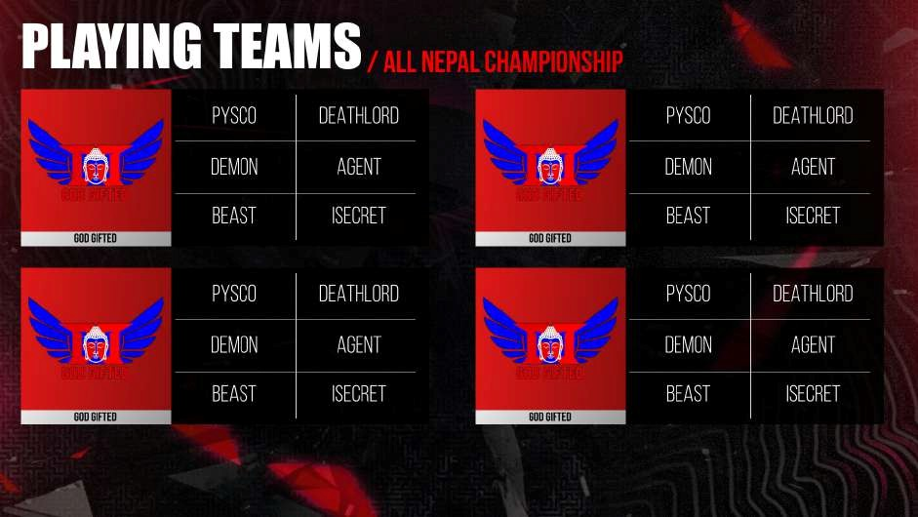

## MATCH-INTRO

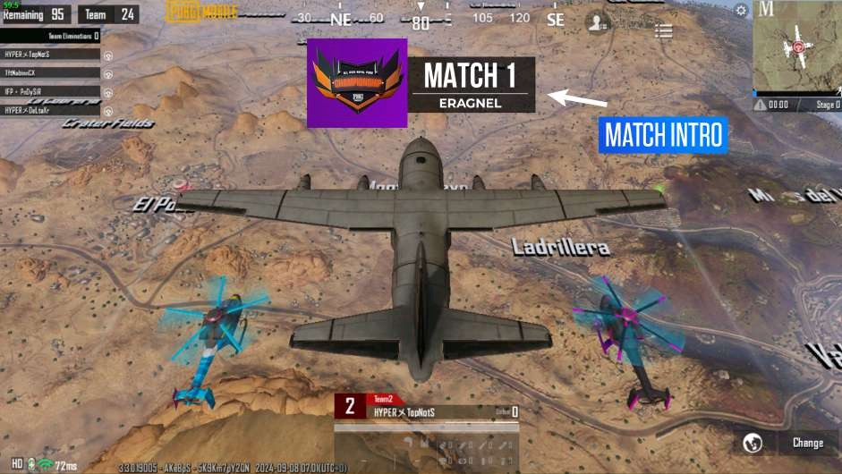

## IN-GAME PLAYER STATS

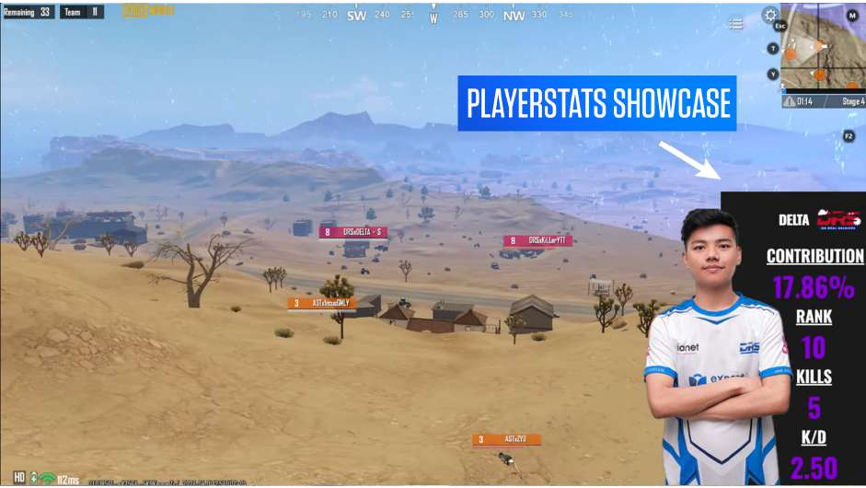

## UPPER-STATS

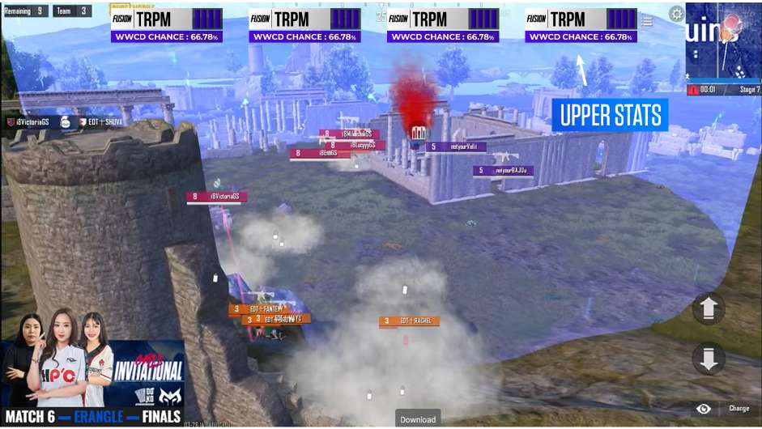

## ZONE-TIMER

